MSW1 Semester 2 SSLC

1/12/23

Representatives: Andrew Bergquist, Kenna Harpell, Salina Yun
Staff: Mary Mitchell (PD; CO: Social Work with Individuals and Families), Steve Kirkwood (CO: Working with Risk, Trust & Complexity); Anne Spiers (CO: Professional Practice in Social Work 2)
Apologies: Sangeeta Chatterji (CO: Doing Social Work Research); Will Rennie (Student Adviser) Intro
- SK: introduced participants and explained purpose of meeting. Sangeeta Chatterji not attending
as it was thought best not to have more staff than students present.

Student Feedback
- KH: weren’t sure quite how feedback should be reported. The responsibility as representatives to feed back the views of peers had to be weighed against how constructive it might be, given that it might be difficult for staff to hear. Decided to use direct quotes where applicable.
- SY: it’s meant to be constructive. Although the feedback may be difficult, this is a platform to be constructive and useful for students moving forwards. We tried to select quantitative data this time, which we’ve done for all 3 courses:

Working with Risk, Trust and Complexity (sample size: 12)
- SY:
  - the majority of respondents found the course helpful or very helpful, gaining new and relevant information about practice
  - tutorial discussions were found to be largely helpful, more so than the readings. The two combined were considered useful.
  - the course was largely found to be intellectually stimulating, useful in terms of progress towards their degree and confidence-building in terms of future practice (though a quarter of respondents did not agree with the latter)
  - a majority of students agreed that lectures were engaging and well-organised
  - regarding assessment, students largely agreed that the type of assessment was fair and effective (although a quarter of respondents disagreed)
- KH: in terms of direct quotes from students:
+
  - Steve Kirkwood (Course Organiser) was praised for being available for help
  - students believed they were able to quickly apply the knowledge they had with what they were learning
  - the workshops were very, very popular (esp. Caledonian Project): the speakers were good and students responded very well
-
  - some students thought tutorials tended to be dominated by the more vocal students, and also that some tutors allowed the tutorial discussions to veer away from the readings and not really return to them
  - some students felt a whole lecture on ‘trust’ was too much time – perhaps half a lecture would have been more appropriate; also on lectures, it was noted that some featured more discussion
  - regarding EAL assessment, students commented that 15 minutes wasn’t enough time to adequately cover questions of the scope that had been asked for, and there were

mixed feelings about mixing the students with the undergrads
    - SK: the mixing of UG and PG students was simply logistical due to the number of groups – attempted to avoid mixing but it would have meant having to have too many presentations than could fit into a single session

- SK:
This is really helpful feedback. Very few people completed the course survey, which is a long- standing problem, so it was unclear what students liked or didn’t like – this is much more detailed than anything that’s been available for the last 3 years. Feedback around tutorial is particularly useful – the readings have been assigned for a while now and are overdue for a refresh. The prompts we use in assessment are also worth reconsidering.

Some specific points: on the lecture on trust, is the above a widely-held view? We could not have a lecture on trust, but it might be weird not to and might raise questions if we do have lectures on the others. Or should the lecture perhaps be doing something different?
  - KH: I think the way the info is presented and how trust is engaged with in the lecture could be done differently – it was ‘trust’ in a very general sense and might be helpful to apply it more directly to social work.
  - SY: the assigned reading for the week on trust was very helpful, maybe even more so than the lecture in covering the definitions of trust in this context. Given that, maybe lecture time could have been re-oriented and made more situational rather than theoretical.
  - SK: that’s really helpful. We can look at that lecture in particular with an eye to making it more applied, perhaps exercise-based.

On the EAL presentations being too short, again is this a widely-held view?
  - KH: this also came up last year. The topics are considered valid and interesting but there is so much information that it’s hard to know what to include, and it wasn’t always know where marks may be lost by not including certain info.
  - SY: part of the feeling of not having enough time may be related to grading - students weren’t always aware of the rubric and some were concerned that not mentioning all 3 concepts would see them graded down.

Doing Social Work Research
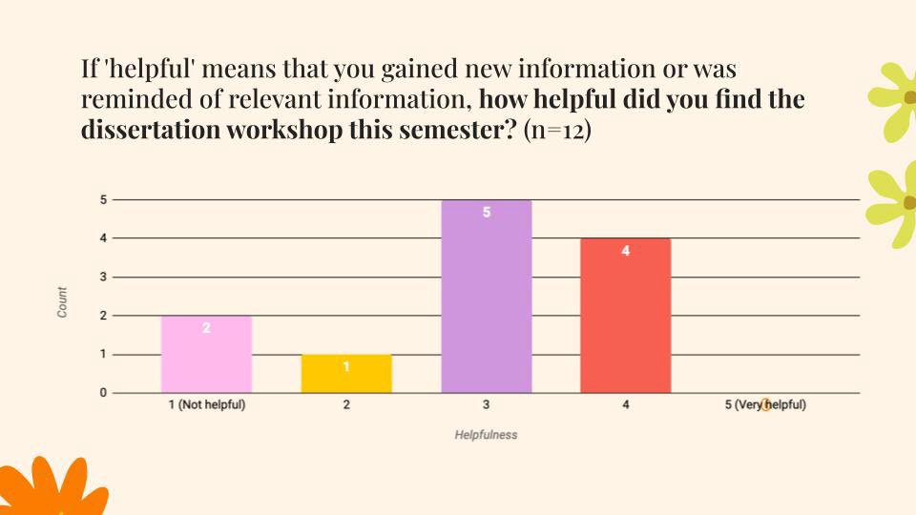
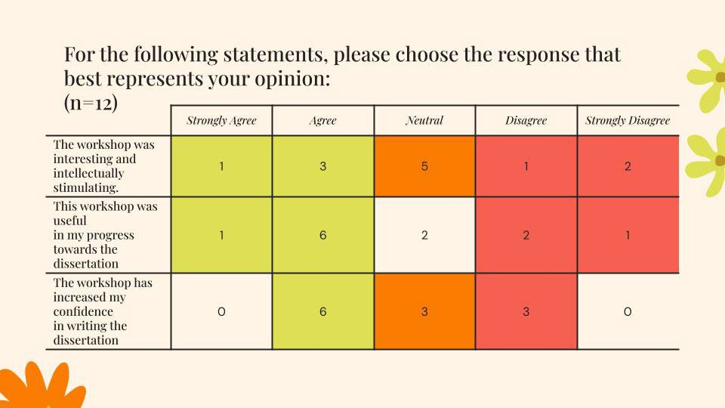
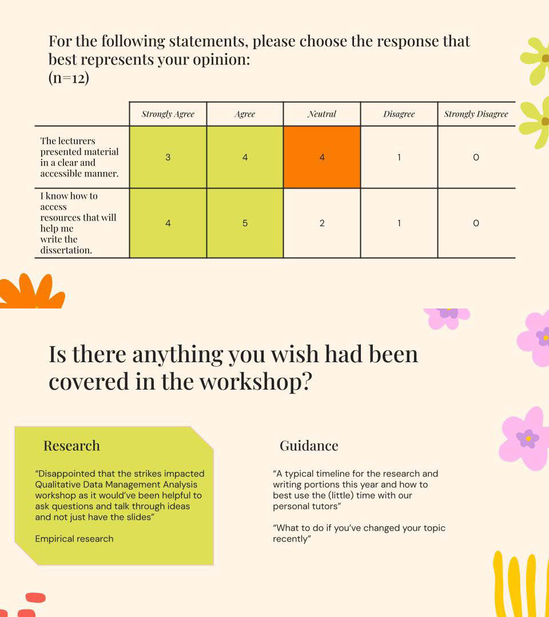
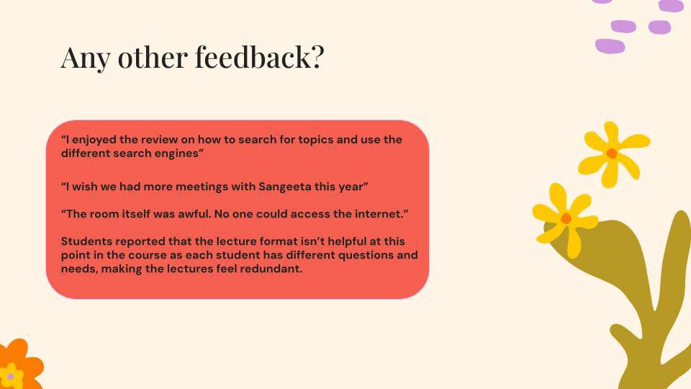
- for the sake of time, this course’s feedback was provided after the meeting. However, is included below:

Professional Social Work Practice 2 (sample size: 12)
- SY:
  - a majority of students did not find the lectures to be very helpful – most were neutral to disagreeing with the statement that the lectures were helpful
  - a majority didn’t find the course to be interesting or intellectually stimulating, did not they think it was useful in preparing for the practical aspect of placement and did not agree that the course increased their confidence about going out on placement
  - there were mixed responses around how engaging the lectures were considered to be and around how well the course was organised – this may be related to industrial action and problems with room bookings. However, there was clear agreement that the lectures were presented clearly and accessibly
- KH: in terms of direct quotes from students:
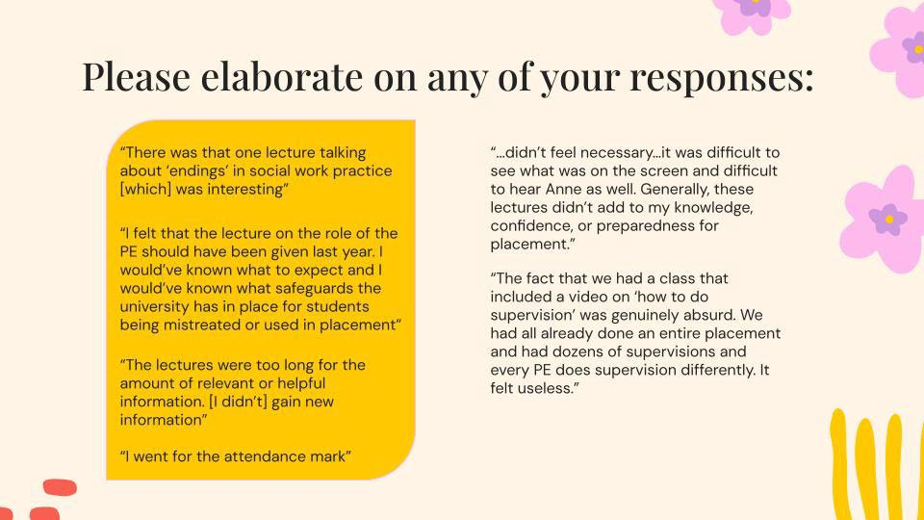
-

  - AS: there are some comments in there which echo some of my feeling about the structure of the PSWP courses in combination – some of the content e.g. around supervision could be swapped around, which would seem quite simple.

PSWP2 is a strange course in that it requires making assumptions about whether people have certain experience, which would make it unnecessary to re-cover it; however, if this were to be excluded it can become clear that people haven’t had it, don’t remember it or interpret it differently. This has been a struggle, and alterations have been made from last year in an attempt to better balance the need to help those catch up who needed it while not wasting time for those who didn’t – but it seems the balance may not have been struck quite right. Not entirely surprised by some of this feedback. We need to look at both courses together, re-shuffle some material and re-visit the reading lists.

In terms of timetabling, the lectures were moved to an unsuitable room and also on a Wednesday afternoon – this didn’t facilitate interactivity in sessions and I’d agree it felt quite chaotic.
  - KH: maybe a confidence check survey would be useful at some stage? A sort of “how are you feeling about x, y and z?”
  - AS: there could be more connectivity between placements. However, we can’t cater for everyone in terms of second placement as there’s a lot of disparity in experience, where people are at in terms of their thinking and there’s also a lot of anxiety. It’s due a revamp, and this will be helpful – the honesty is appreciated.
  - MM: just want to acknowledge how much Anne’s had to deal with, and thanks for that. It’s been really difficult, and a lot of it has landed on Anne’s desk but she’s been flexible and has communicated with students as best she can.

- KH: there were some positives:
  - students felt they could reflect on their previous placement (although one commented that it was good to find out what their Practice Educator was supposed to be doing)
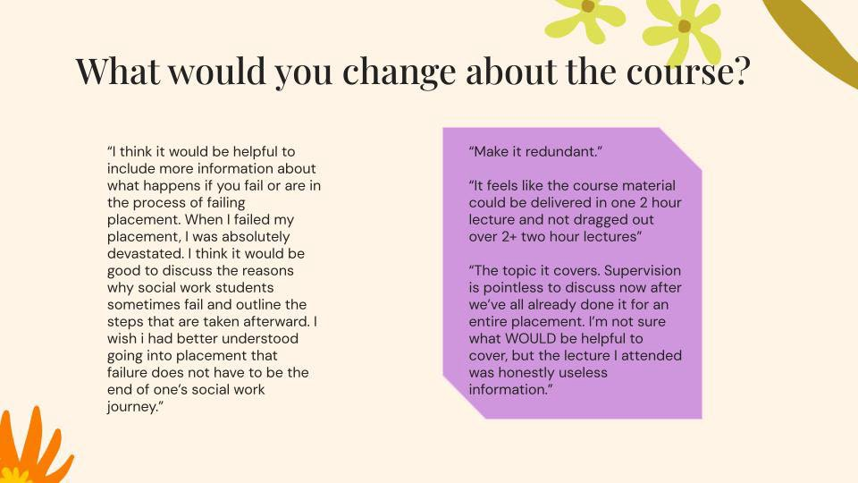
- KH: in terms of suggested changes:

  - AS: talking about failure on placement can have a really negative impact on students who are about to embark on an enjoyable but stressful experience. We do have strong responses and mechanisms in response to failed placement but will need to discuss further with the Practice Learning team around transparency here. It’s not unheard of for students to be surprised they can fail a placement.

Content about supervision was ultimately included because students do reflect and decide to approach supervision differently on second placement. This can be minimised though – a specific video is used for both this and another aspect of the course and perhaps this should only be used once.

The course also has a self-study element, for which the preference would be an in- person workshop. However, timetabling logistics didn’t allow for this.
  - MM: it would be really useful to know what would be useful for students, given you’ve been in placement. It sounds a bit like the feedback is that the course isn’t really needed, but losing this would mean students did not have the base to speak together about placement: the fears, the risks, what’s gone well and not so well. But it does sound like there’s some work for us to do here, if students could help us understand what would be useful.
    - SY: there’s some clarity lacking around the competency checklist, and what are the concrete social work skills that students should be gaining on first placement (e.g. taking clear case notes)
    - KH: this also depends on the kind of placement, as not all placements will be able to provide the chance for students to develop all skills
    - AS: recent meeting with practice educators suggested that there is a gap between the range of essential skills which are teachable on a given course, and the full range of skills that might be required in any social work placement. This has been woven in into e.g. Working with Self and Others’ focus on case notes, and I’d like to see reflective writing added somewhere else, with PSWP1 and PSWP2 pulled together as well to make sure we’re covering these skills
- KH: would it be possible for us to speak to the cohort at the next recall day to pass on a survey to them to answer at that moment? This would probably mean we’d get a lot more feedback.
  - AS: my only reservation is that we’d be asking students at a point when they’re having very different experiences – depending on where they are in the journey, the answer may be very different. This isn’t to say not to do it, but perhaps let’s think about what we’re

asking. However, I’d love to capture more information and for you to conduct a poll of some sort, for example.
  - KH: I’d be happy to help sort this out.

General Programme Feedback
- SY: there were mixed feelings regarding the adequacy of current assessment methods (essays and EAL presentations) in allowing students to demonstrate their knowledge of course content
  - KH: to add to this, past SSLCs have included discussion about how essays and presentations don’t lend themselves very well to neurodivergent students’ ability to demonstrate their learning. Appreciate that there are bigger institutional factors at work but wanted to provide some data on this question.
- SY: there were also varied results in responses around effectiveness of programme in preparing students for practice and value for money
  - KH: we can ask further questions to tease out the particulars of some of this data
  - MM: it’s difficult to respond fully as there’s a lot here. However, I’d agree that tuition fees are an enormous cost. There’s an interesting dilemma in the statistics provided which is that the majority of students feel the programme is preparing them for practice but yet isn’t worth the money, and I’d like to know what that’s about – just the fees, or also the quality of teaching? So they’re quite broad statements which I’d agree with in part, but it’s hard to know what the next question to ask is.
- MM: were there any other comments you wanted to discuss?
  - KH: our peers gave very direct, even raw, feedback and we have a duty to them to present it.
  - MM: it’s great to have the feedback – it’s of high quality and nobody is taking this personally. There are certainly grounds for improvement. The question is what to do with this feedback.
  - KH: it would be great to have the chance to have an open discussion on recall day if possible.
    - AS: one of the things which happens on recall days is that everyone wants to borrow time when everyone is together. However, the negative aspect of that is that the form of the day can be lost. In addition, recall day is very placement focused which may skew the results which are gathered.
    - MM: I’d agree with this. It’s often a very emotional space for students and not the best opportunity to evaluate the programme as a whole. However, we’re organising a recruitment evening on World Social Work Day (the following week) and the idea was to do an evaluation of the programme at that point. You may not get such honest feedback in person though: we need to think about how to get feedback and key questions on what’s working and what’s not. There’s a lot of negative feedback here and just a reminder that this can also be directed to the Programme Director rather than you taking responsibility for it yourselves.
    - SK: I wonder if we need to find spaces to have dialogue about how we improve things. These might be smaller-scale, at course level. One of the questions which was interesting was around assessment – it is difficult to assess student skill, using the typical tools the University tends to apply. We go back and forth on this a lot. Neurodivergency is also something we need to pay greater attention to and we’ll need to take this away and have proper dialogue about it.
    - KH & SY: Happy to help if possible.

Any Other Business
- MM: we’re in the process of organising an end-of-year ceilidh and I’d like to ask if you would be happy to help in this. Jessie from the SDO will be in touch to organise a ceilidh.
  - Reps: happy to help.
- MM: it’s been very good to get straight feedback – it’s what we’re looking for. It’s been difficult to gather feedback from students via the official form and we really appreciate the work you’ve put in.
- AS: to reiterate the point about recall days and how they’re used, I’d be interested in looking at information gathering concerning what would be useful for practice placement 2. There may be a slot at the recall day, and your ability to handle the tech around gathering this info on the spot would be very helpful. A short survey would allow me to capture some of the recommendations for both placements.

