Agenda and Action Tracker
BSc3/MSW1 Semester 2 SSLC

6th March 2025 Meeting Via Teams

Student Representatives: Apologies:
BSc3: N/A MSW1: Andrew Sinicropi
MSW1: Jyotika Kumar

Staff: Apologies:
Eve Mullins (PD, BSc; Acting PD, MSW) Steve Kirkwood (CO: Doing Social Work Research)
Avril McIvor (Director of Practice Learning) Hadijah Mwenyango (CO: Understanding Care and Control in Social Work)
Will Rennie (Student Adviser)

Introduction
EM welcomed and introduced attendees.

Understanding Care and Control
- JK: 9 out of 14 students responded. Really positive feedback.
  - students liked the condensed format and rated content and resources highly (4/5)
  - they also reported that the course has improved their knowledge
  - response to feedback was more mixed. Some people weren’t happy with their essay feedback, but didn’t elaborate much on that.
- HM: happy that the content was enjoyed. This was a collective effort from staff. Perhaps if we’d had more idea of what was expected from feedback, it would have been better.
  - JK: this isn’t recorded in responses, but from speaking to classmates feeling is that the feedback isn’t specific enough. Overall feedback makes sense but they’re not able to break down where marks are being deducted. Positives are much clearer. This was also the case in semester one.
    - EM: that’s good to know, thanks.
  - AM: as CO of this course two years ago, it sounds as if the way feedback was delivered this year reflects changes made after a previous cohort said feedback was too critical, and could there be more of a focus on positives. This isn’t to reject your cohort’s response, just to put it into context. It sounds like this is still a work in progress.
    - EM: always a challenge getting the balance right with feedback. Understandable that students want to know where they can improve marks. I wonder if we can also do more in raising student awareness that they can talk to the marker about their feedback.
  - JK: this sounds good. Didn’t realise this was an option, but people would surely take this opportunity.
- JK: there’s also a conception that the entire marking process is confidential, so there’s a consciousness that a discussion about marked work might create a sort of bias.
  - EM: it’s totally anonymous before the marks are given, but once marks are ratified then student names are released. This isn’t sent back to markers directly though, so the only way a marker could see a given student’s marks would be to check EUCLID. Even then, they wouldn’t know if this student’s essay was one that they marked. But students are able to see who the marker is, so can come to speak to us (marker, CO, PD) for clarification. This part doesn’t need to be confidential.
- JK: personally speaking, also think it would be beneficial to advertise extra support for academic writing (SDO, IAD etc.)
  - EM: that’s helpful, thanks. We’ve got a lot of info about what’s available but it’s good to clarify in these meetings what students are and aren’t aware of.

Placement

- EM: realise you’ve only just started placement but the teaching period has finished
- JK: lot of anxiety about placement, which everyone has faced.
  - lot of uncertainty about what it will look like in practice. The idea of placement is quite intimidating culturally and in a lot of other ways.
  - desire for some in-house training beforehand, even if basic – there’s understanding that this will be provided on-placement, but this was a source of anxiety. A bit of pre-placement training would ease the transition.
  - otherwise, there’s a recognition that it’s still a transition period so not much else feedback so far
- AM: any suggestion of what this training might involve?
  - JK: interaction. Hasn’t been very much interaction with service users. There have been workshops, but these were organized more by organisations than involving service users directly. Grassmarket workshop was the exception, and this was really great for everyone.
  - AM: so rather than training, it might be more a question of greater exposure to service users?
  - JK: yes.
  - AM: we can certainly follow up to see if that can be boosted a bit more. Particularly for MSW1 students, we’d like to get that early experience in. Really helpful feedback.
  - EM: we’ve been discussing how to facilitate this within the constraints that we’re working in. Thanks.
- JK: I spoke to a placement colleague about an observational placement they did. Thought this was worth mentioning.
  - AM: we had to retract the offer for this sort of placement because there’s a shortage of placements, and we were finding that agencies involved in taking placements couldn’t then commit to taking on a first or final placement. However, it’s worthwhile looking at again specifically for MSW1. Don’t want to promise anything though as there are still constraints on placements in Scotland, and also financial restrictions because SSSC now don’t pay for observational placements, which agencies need to receive payment for. However, we added the observational placement days to SWIF, and perhaps we can boost service user contact on this course.
  - EM: also considering if we can add contact with non-peers in Working with Self and Others. This might help with feeling more prepared to have challenging conversations with people you don’t know. Nice to hear that your experience is in line with our thinking about how to improve.
- JK: happy to collect a feedback form when placement is completed.
- AM: could you please communicate a ‘thank you’ back to your cohort? You were a test cohort for a change we made regarding making agency introductions largely before Christmas (previously it was done after the January exam boards). This was a risk we decided to test in consultation with your cohort, as there was a chance for some students that they might not progress to their placement if they didn’t complete some of the prior courses. We were also a bit concerned that the foreknowledge of where you’d be going on placement may lead to a great increase in e-mail traffic, but you handled it really well and it allowed us to get to placement planning much quicker and more smoothly. We think the agencies will see the benefit of this longer preparation period too. Thanks so much for managing that extremely well.
  - EM: if we do another round of feedback at the end of placement, it would be good to get impressions on the timeframe and whether they felt there was enough time to prepare.
  - JK: it worked really well. Everybody knew what was happening, what it would look like, and it was easier to connect with people already working on placements (via social media etc).

Doing Social Work Research
- JK: 4/5 generally. Number one complaint was that the classes were too early. I didn’t get specifics, but it was also reported that a lot of the content was “obvious,” or already known. Aside from that, nothing major.
  - JK: people also said a lot of classes were great when the content was new (e.g. wildcard while using Google Scholar).
  - EM: will feed this back to Chris to inform his thinking and course design going forward. In semester 2, would it be more helpful for the 2-hour classes to be run more like workshops rather than lectures?
  - JK: think that would be helpful. People respond better to a mixed format because it’s more interactive.

AOB
- EM: anything we’ve missed or you’d like to add?
- JK: general consensus that classes in semester 2 were only running two days a week and people weren’t really sure how to best use the rest of the time they had. Wondering if they could be spread out a little more evenly through the week.
  - EM: similar to above, we’ve had cohorts in the past who asked for classes to be less spread out so they could work, or manage childcare or travel. Difficult to get the balance right year-to-year. Understand that for international students this time can feel quite unstructured.
- JK: we were told that student reps could organize a cohort event every year and if more info was available that would be useful. The cohort’s been asking if this sort of thing could happen.
  - EM: I can send you some information about who to contact in the Student Development Office. Events that we organize on behalf of the cohort are a Welcome Week event and a tea/coffee meeting at the start of your second semester of Year 1. In Year 2, there’s a careers fair and we support you to organize an end-of-year celebration with the UGs. But you can also organize your own events.
  - AM: just a note that it can’t be during placement as SSSC regulations only allow a certain number of days for students to be back at the University during placement. It could be in the evening or at the weekend but you need to consider students who may be doing shift work on placement.
  - EM: I know there’s a budget for this which the SDO can advise on.
- EM: have minimal feedback from BSc3s which can be e-mailed to COs and added to the minutes. Thanks everyone.

BSc3 Feedback
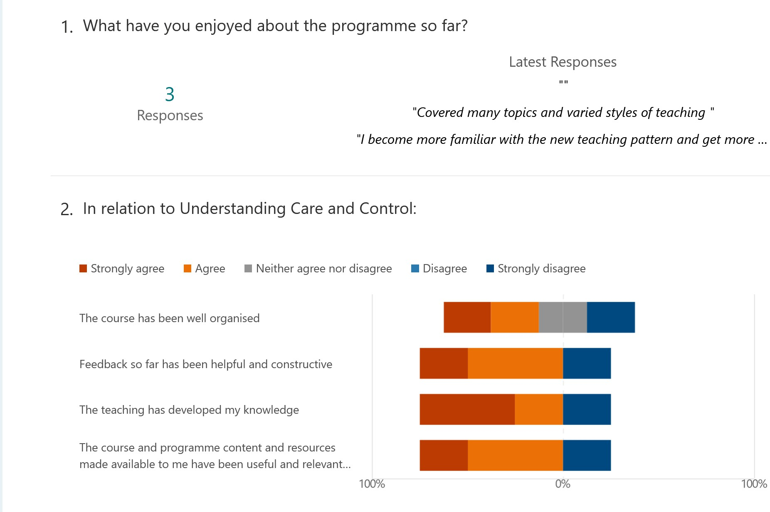

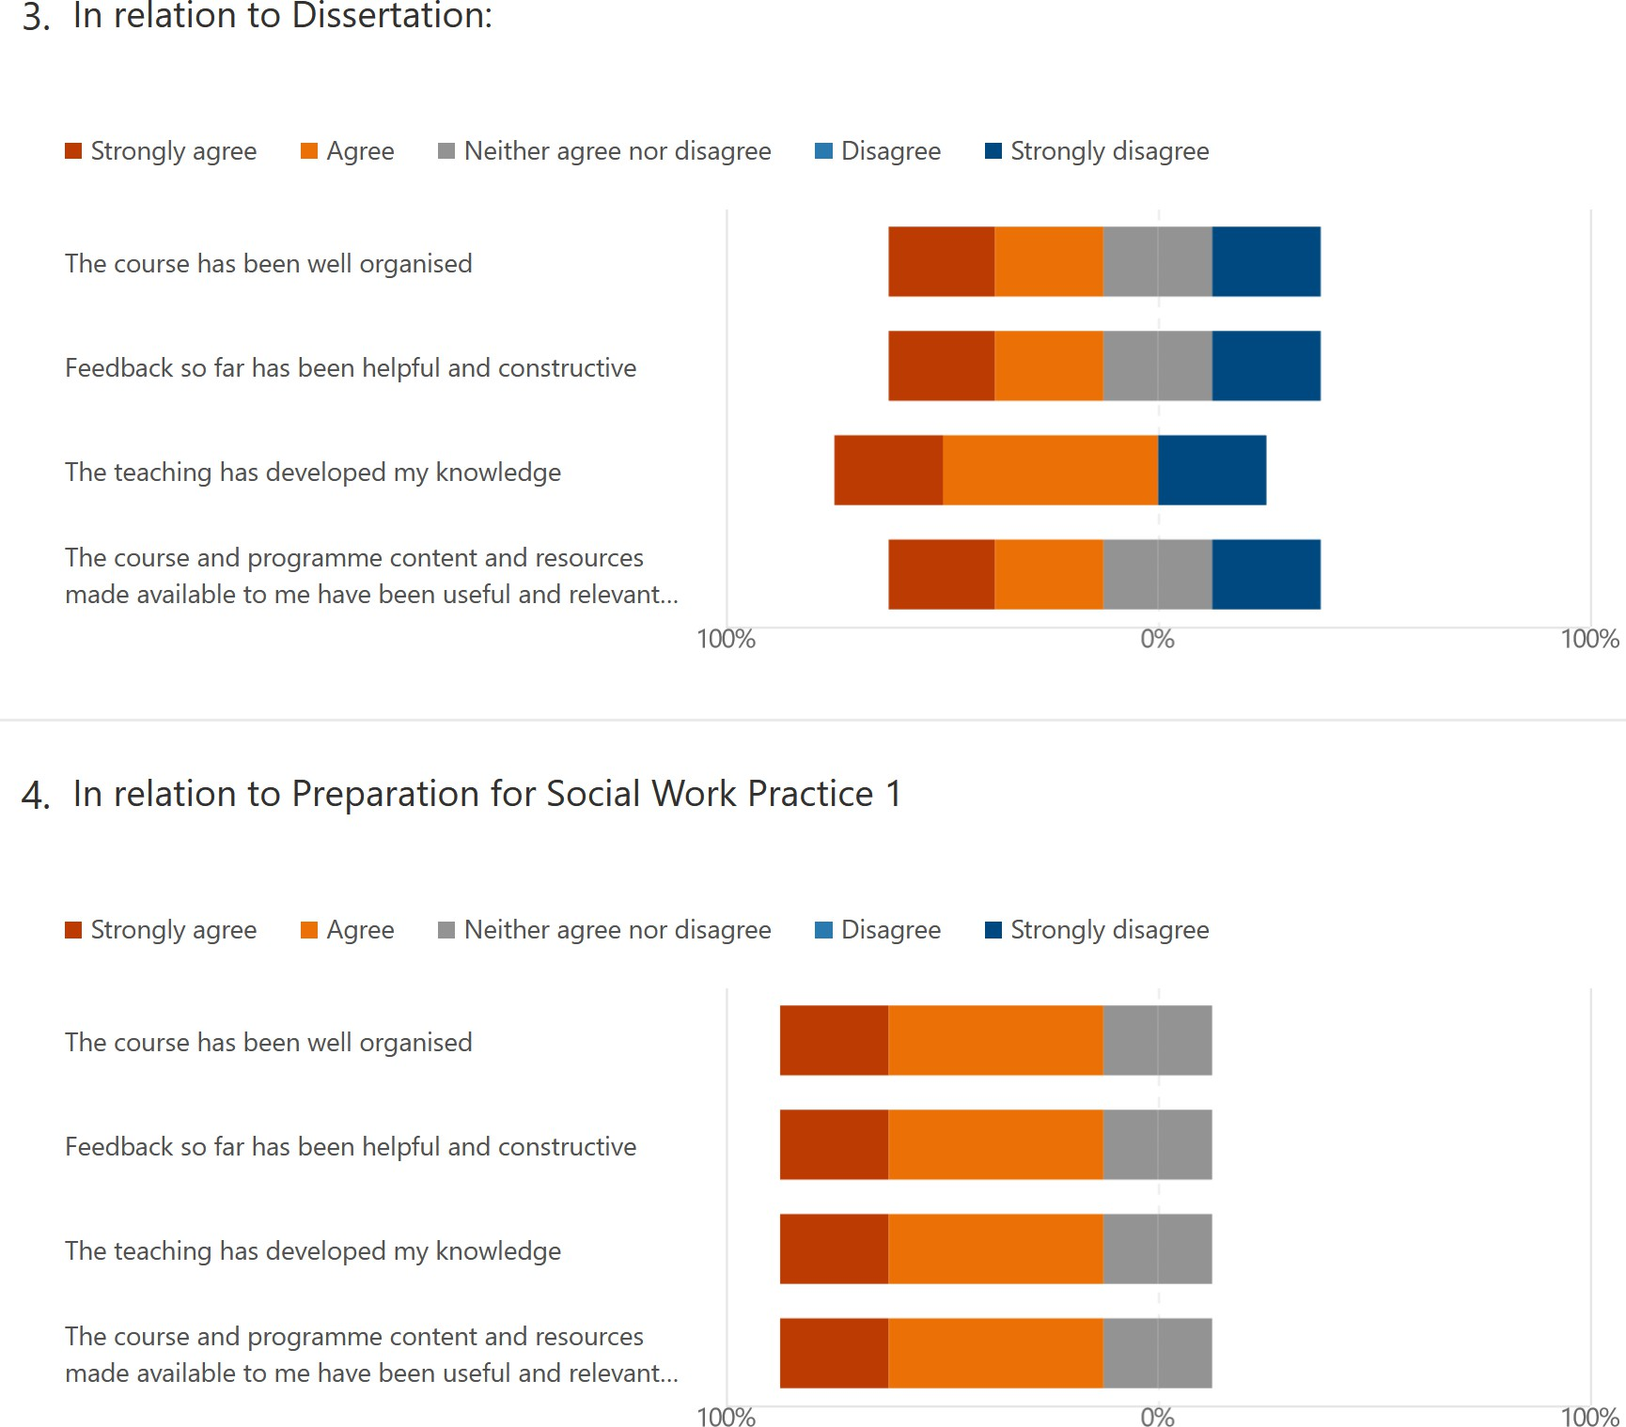
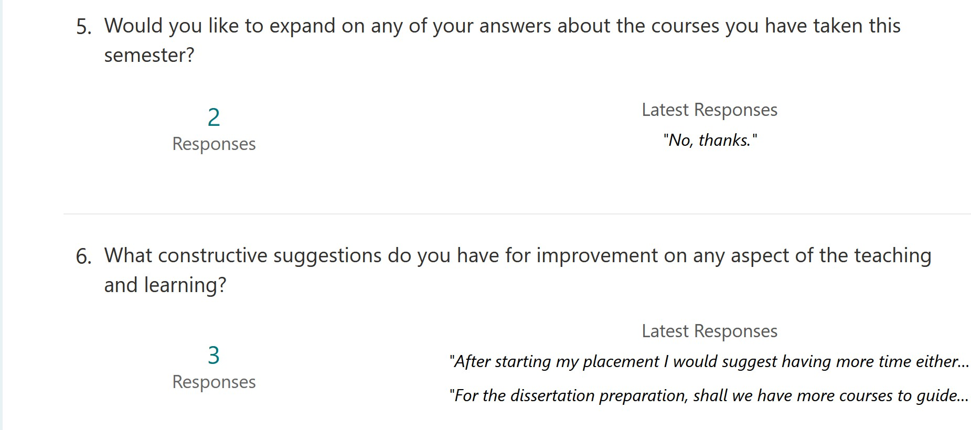
- NB: Comments are:
  - After starting my placement I would suggest having more time either in lectures or tutorials focusing on how to assess a case study for risks and need
  - For the dissertation preparation, shall we have more courses to guide how to determine the topic of dissertation please?

- In relation to cohort building and the wider social work community:


  - Strongly agree ■ Agree ■ neither agree nor disagree ■ Disagree ■ Strongly disagree ■ not applicable I have felt part of the year 3 BSc social work student
community


I have felt part of a wider social work student community with my peers on the masters programme


I would like more opportunities for social engagement as a year group


I would like more opportunities for engagement with the subject area and staff team
100% 00/o 100%

- Would you like to expand on any of your answers above?

2
Responses
Latest Responses
"No, thanks."

- Self reflection on your effort


  - Strongly agree ■ Agree ■ Neither agree nor disagree ■ Disagree ■ Strongly disagree I am happy with the effort I have put into the courses
across the semester


I read the course information on Learn (e.g., learning outcomes, assessment, academic misconduct)
100% 00/o 100%

- Would you like to expand on your answers above?

2
Responses
Latest Responses
"No, thanks."

- Is there anything in particular you would like the staff team to know?

2
Responses
Latest Responses
"No, thanks."

Action Points

Course/Action | To be Completed by | Completed/Date
All Courses
- raise student awareness that they can approach markers with questions about feedback  - advertise extra support for academic writing (SDO, IAD  etc.) | Course Organisers Programme Director
Placement/WwS&O
- greater exposure to service users | Director of Practice Learning (Incoming) Programme Director
Doing Social Work Research
- 2-hour classes to be run more like workshops than lectures | CO: DSWR  Programme Director

